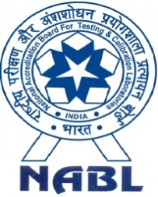 | National Accreditation Board For Testing And Calibration Laboratories  (A Constituent Board of Quality Council of India) | 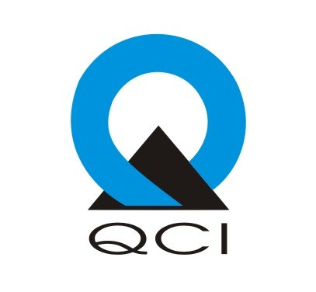

3 Days Training program on “General requirements for the competence of Reference Material Producers as per ISO 17034:2016
HYDERABAD
9th -11th Jan 2020

23rd-24th January, 2018 at Ahmedabad

