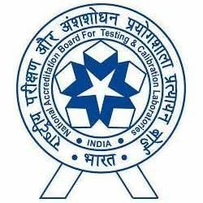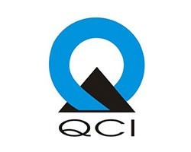
Seminar: Recognition Scheme for Sample Collection Centre/Facility (SCF) of Medical Laboratories August 28th, 2018 at Indian Habitat Centre, New Delhi

NABL has initiated a recognition scheme of sample collection centre/ facility associated with medical laboratories. This has been designed and developed to ensure the quality of services rendered by these sample collection centres/ facilities. This will involve assessment of all declared sample collection centres/ facilities which will ensure integrity of samples and better control on pre-examination processes as quality of test results largely depends on these processes.
NABL is pleased to announce one day Seminar on Recognition Scheme of Sample Collection Centre/Facility on August 28, 2018 at New Delhi (Between 11:00-17:00Hrs)
KEY OBJECTIVES:
- To share details of Recognition Scheme for Sample Collection Centres/ Facilities and Procedure
- To explain methodology of Mobile Application based assessment.
- To strengthen pre-examination processes of accredited laboratories
- To encourage other sample collection centres/ facilities for the recognition through NABL laboratories.

Who should attend?

- Laboratories (Applicant, Accredited)
- Collection Centres
- Franchise Collection Centre
- Owners of SCF
- Facilities involved in Sample Collection

Benefits of Scheme:
- NABL Recognition of Sample Collection Centres/Facilities as authorised Collection Centre.
- Increase in patient satisfaction, patient trust on Collection Centre/ Laboratory
- Strengthen pre-examination processes of lab
- Visibility of Collection centre on Google-map

Venue: Indian Habitat Centre, Lodhi Road, New Delhi -110003
For Registration click here
Email-id: sscc@nabl.qcin.org
Website: www.nabl-india.org

For any information/clarification please contact:
Mr Ashok Kumar (0124-4679748, 9555977661)
Mr. Chandrakant Solanki (0124-4679752, 9974218723)

